Ans.1)

1.1) A *Point Estimate* is a single value used to approximate an unknown population parameter. It is derived from sample data and provides the best guess for the true value of a population characteristic, such as the mean or proportion. For example, if we take a sample mean of 63 from a group of students, then 63 will be the point estimate of the population mean.

On the other hand, An *Interval Estimate*, on the other hand, provides a range of values within which the population parameter is expected to fall. For example, we can say the population mean lies between 61 and 65, with a certain level of confidence.

Conclusion: A point estimate gives a single best guess for a population value, while an interval estimate provides a range of possible values with a certain confidence level. Interval estimates are more reliable as they account for variability and uncertainty in the data, offering a broader perspective

1.2) A confidence interval is a range of values within which we are confident that the actual true population parameter lies.

The confidence interval depends on:

a) The sample mean/proportion.

b) The standard deviation

c) The confidence level (like 95%, 99%).

1.3) Given:

n(Sample Size) = 30

x̄(Sample Mean) = 85

s(Sample Standard Deviation) = 6

Now, Using formula

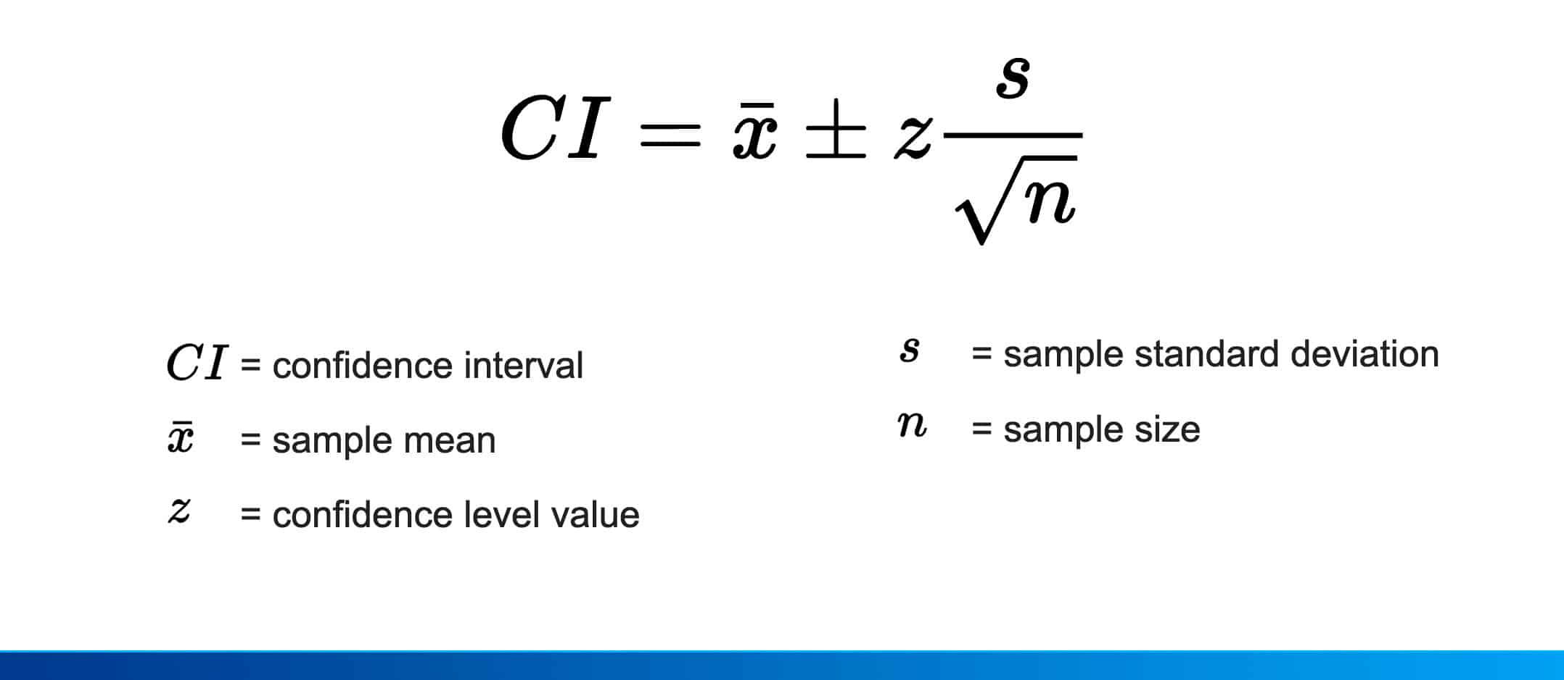

a)*99% Confidence level:*

Z-score for 99% confidence level = 2.576

CI = 85 ± 2.576 * 6 / √30

CI = 85 ± 2.576 * 1.095

CI = 85 ± 2.82

Hence, 99% CI = (82.18, 87.82)

a)*95% Confidence level:*

Z-score for 99% confidence level = 1.96

CI = 85 ± 1.96 * 6 / √30

CI = 85 ± 1.96 * 1.095

CI = 85 ± 2.15

Hence, 99% CI = (82.85, 87.15)

Ans.2)

*A)* Given:

Mean (μ) = 12,000

Standard deviation (σ) = 1,500

Using the **Z-score formula**:

Z = (X - μ) / σ

**(a) Probability of Paying More Than 10,500**

For X=10,500:

Z = (10,500 - 12,000) / 1,500

Z = (-1500)/1500

Hence, Z = -1

From the Z-table, P(Z > -1) = 0.8413

Thus, the probability of paying more than 10,500 = **0.8413**

**(a) Probability of Paying More Than 14,700**

For X=14,700:

Z = (14,700 - 12,000) / 1,500

Z = (2700)/1500

Hence, Z = 1.8

From the Z-table, P(Z > 1.8) = 0.0359

Thus, the probability of paying more than 14,700 = **0.0359**

*B)* Given:

n(Sample Size) = 50

x̄(Sample Mean) = 6.5 days

σ(Population standard deviation) = 2 days

α(Significance level) = 0.05

Recovery time without the drug = 7 days

So, Null hypothesis (H0​): μ≥7 days

Recovery time without the drug < 7 days

So, Alternative hypothesis (Hα​): μ<7 days

**Using Test Statistic Formula**

Z = {(x̄ - μ) / (σ / √n )}

So, Z = (6.5 - 7) / (2 / √50)

Z = (-0.5) / 0.283

*Z = -1.767*

**Now, Critical Z -Value**  
For a 5% significance level, the Z-value = **-1.645**.

**Then,**

Since Z = -1.767 is less than -1.645, we reject the null hypothesis.

**Conclusion:** The company's claim that the drug reduces recovery time to less than 7 days is supported at the 5% significance level.